KIRFs – Year 6, Autumn 1
Target: To know all times tables and division facts.
To multiply with decimals
By the end of this half term, children should know the following facts. The aim is for them to recall them instantly.
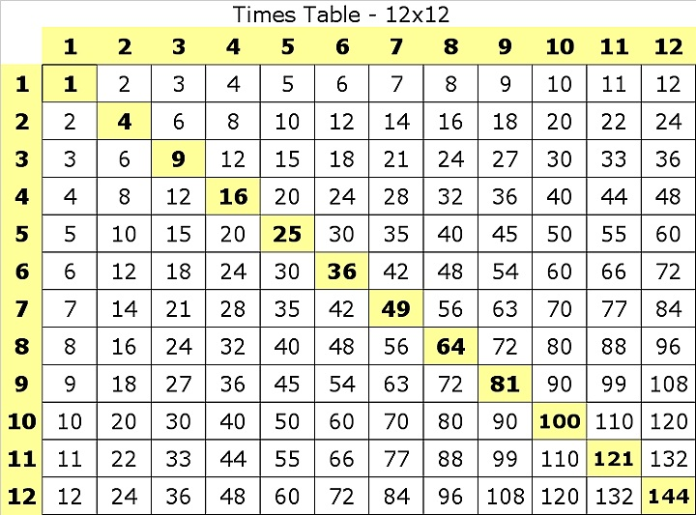
Key Vocabulary

multiplied by

lots of

times

divided by

- All multiplication and division facts are expected to be known by the end of Year 4 and this is a chance for Year 6 children to consolidate their knowledge of multiplication and division facts and to increase their speed of recall.
- They should be able to answer these questions in any order, including missing number questions e.g. 6 x ___= 42 or ____÷ 8 = 4
- Children who have already mastered their times tables should apply this knowledge to answer questions including decimals e.g. 0.7 x = 4.2 or ÷ 60 = 0.7

Top Tips
- The secret to success is practising little and often. Use time wisely. Can you practise these KIRFs while walking to school or during a car journey? You do not need to practise them all at once; perhaps you could have a fact of the day.
- If you would like more ideas, please speak to your child’s teacher.
- Speed challenge – Take two packs of playing cards and remove the kings. Turn over two cards and ask your child to multiply the numbers together (Ace = 1, Jack = 11 and Queen = 12). How many questions can they answer correctly in 2 minutes? Practise regularly and see if they can beat their highest score.
- Online games –Times Tables Rock Stars. Other activities can be found on: www.educationcity.com, www.conkermaths.org, www.timestables.co.uk and www.timestables.me.uk

