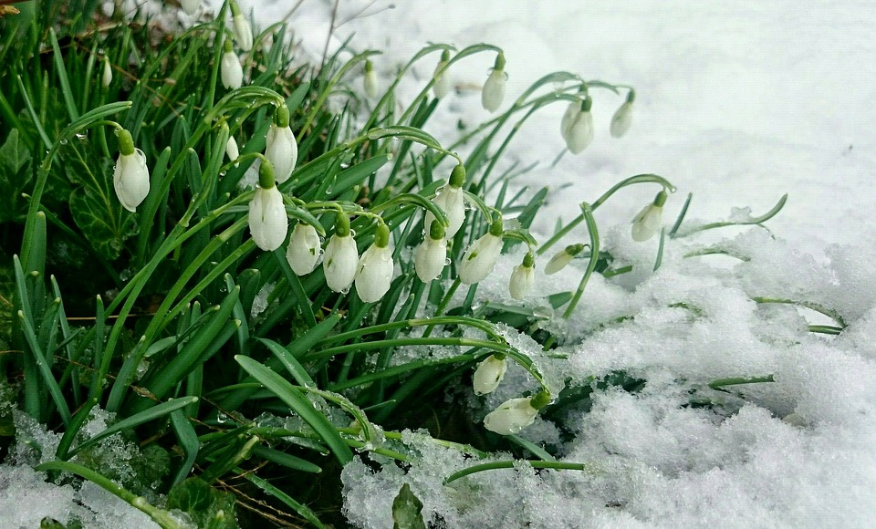
FEBRUARY READING CHALLENGE
This half term, you are expected to complete some reading challenges from the list below. Did you know that children who are more confident readers, approach maths problems with more ease due to the de-coding skills they have learned whilst reading? We want to encourage a love of reading and that can be done in many ways. When you complete a task, put your name on our class challenge board. Have fun.
Read to a pet | Matchbook Summaries:  Create a mini summary matchbook to accompany your reading book. | Choose a word from a book and use a thesaurus to find other words that the author could have used. | Eye Eye:  Fill an A4 piece of paper with a drawing of one character’s eye and what they can see (reflected in their eye). | Listen to an audiobook
Guess my book:  Wrap your book in brown paper and include some clues about the book but nothing more. Return to the library. | New Book Cover:  Design a new book cover with your own tagline and blurb. | Make a den and read in it | Drawing:  Draw a picture of a main character annotated with key quotations that describe them. | Read a book that you loved when you were younger
Collage:  Create a collage about your book using both images and words. | Song or rap:  Write a song about your book. You could perform this in class. | Cereal Box Book Report:  Create a cereal box book report. | Animation:  Create a stop frame animation about your book. | Map:  Draw and label a map of the main setting(s).
Baking:  Bake a cake response to your book. Remember to take a photo before it gets eaten… | Read a comic | Sculpture:  Create a sculpture in response to your book. | Read when you’re out!  Read a book when you’re out. Where will you read? | Read a book about your hobbie or one of your interest e.g. superheroes, horses.
Goodreads:  Write a Good Reads book review. | Portrait Painting:  Paint a portrait of a main character. | Comic Strip:  Draw a comic strip for part of the book. | Speech:  Write a persuasive speech convincing your class to read your chosen book. | Social Media:  Mock up a Facebook or Twitter page for one of the main characters.

