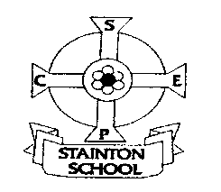

Friday 5th September
Year 5 Fantastic Friday
Dear Parents and Guardians,
In Year 4/5, the children are given the opportunity to share their interests as part of Fantastic Friday. Every two weeks, each year group are given the opportunity to share their interests: starting with Year 4 on 12th September. Year 5’s first Fantastic Friday will be on 19th September. Over the years, children have shared projects they have been working on at home, crafts they have completed, music skills, sporting achievements, science investigations, singing, dancing and many more activities besides. However, they don’t have to share anything if they don’t want to. Sometimes, the children like to bring in cooking to share. Please sign and return the form to give permission for the children to taste the items that are brought in. Please let us know of any allergens in the recipes using the attached sheet. I will have additional allergen sheets kept in the classroom.
Kind regards,
Mrs Campbell.
---------------------------------------------------------------------------------------------

Year 4/5 - Fantastic Friday

I give permission for my child ……………………..………………..……………………………………. to take part in the above activity.


