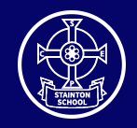

Stainton C of E Primary School
Fairybead Lane, Stainton, Penrith, Cumbria. CA11 0ET
Email: admin@stainton.cumbria.sch.uk
Telephone: 01768 840673
Website: www.stainton.cumbria.sch.uk
Newsletter: April 2024

Please click on the link below (green button) to access this month’s newsletter.
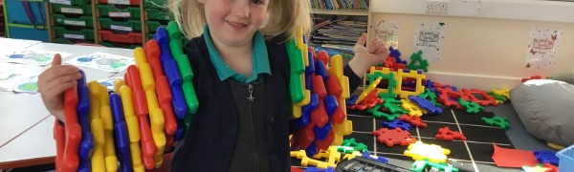
Stainton CE Primary School Newsletter: April 2024
In this newsletter we will be sharing:
Go to this Sway

https://sway.cloud.microsoft/IQRTGSwg0GJGzMaD?ref=Link

Please do not hesitate to contact us if you have any questions regarding the content of this newsletter!
Stainton CE Primary School: Love one another as I have loved you (Jn 13:34)

