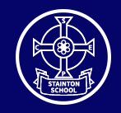

Stainton C of E Primary School
Fairybead Lane, Stainton, Penrith, Cumbria. CA11 0ET
Email: admin@stainton.cumbria.sch.uk
Telephone: 01768 840673
Website: www.stainton.cumbria.sch.uk
Newsletter: November 2023

Please click on the link below (green button) to access this month’s newsletter.
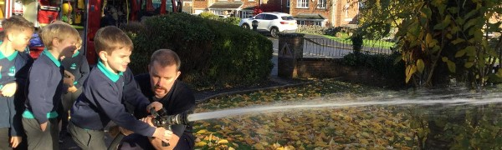
Stainton CE Primary School Newsletter: November 2023
A warm welcome to your November Stainton School Newsletter. What a busy month we have had so far and I am sure that as Christmas approaches it is going to get even busier! Please keep your …
Go to this Sway

Please do not hesitate to contact us if you have any questions regarding the content of this newsletter!
Stainton CE Primary School: Love one another as I have loved you (Jn 13:34)

