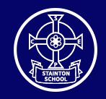

Stainton C of E Primary School
Fairybead Lane, Stainton, Penrith, Cumbria. CA11 0ET
Email: admin@stainton.cumbria.sch.uk
Telephone: 01768 840673
Website: www.stainton.cumbria.sch.uk
Newsletter: September 2023

Please click on the link below (green button) to access this month’s newsletter.
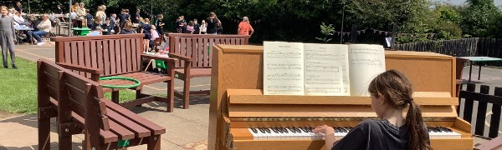
Stainton CE Primary School Newsletter: September 2023
A warm welcome to your September Stainton School Newsletter. We are thrilled to be sharing so much with you, the children and teachers have had a busy start to the term.
Go to this Sway

Please do not hesitate to contact us if you have any questions regarding the content of this newsletter!
Stainton CE Primary School: Love one another as I have loved you (Jn 13:34)

